Your starting point is the completed version of Exercise 6.3. If you already closed that file, please reopen it using the Power BI software. You should first complete the previous exercises before starting with this one. If you just wrapped up the last assignment, your view would probably look like the image below.

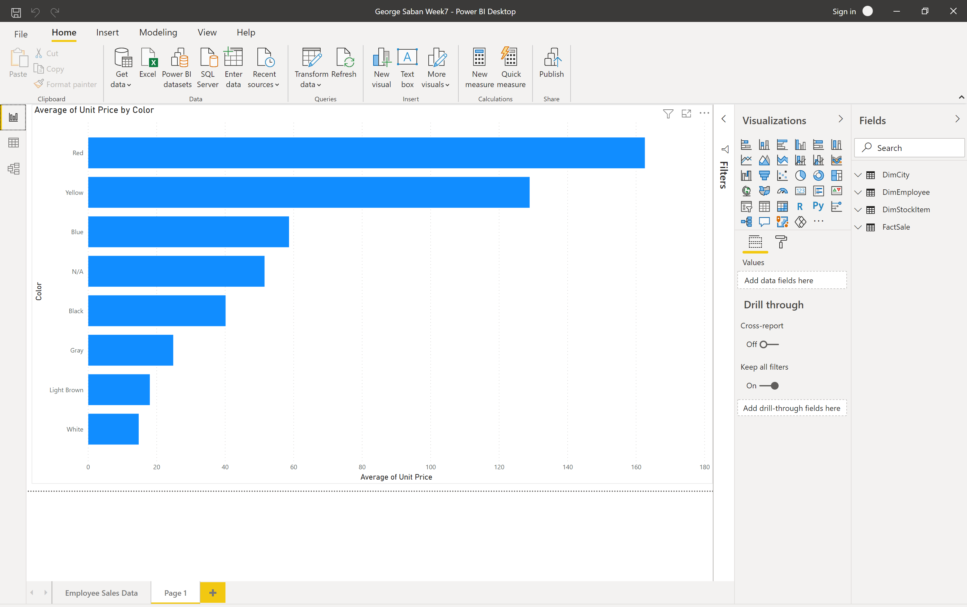



Let’s continue cleaning up the data. Go to the Power Query editor by clicking on Transform data from the Home tab.

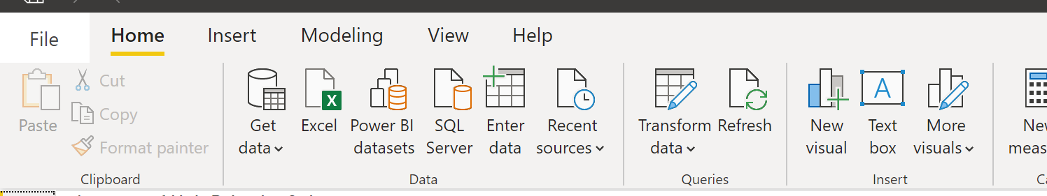



This will open up the Power Query editor.

Select DimStockItem

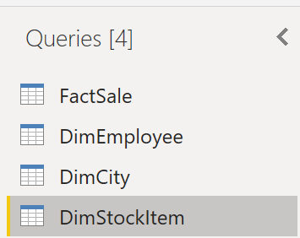



Scroll right to find the “Recommended Retail Price” column. Note that there is something wrong with the data on this field. The question mark character mostly indicates that there was a defect during the import procedure.

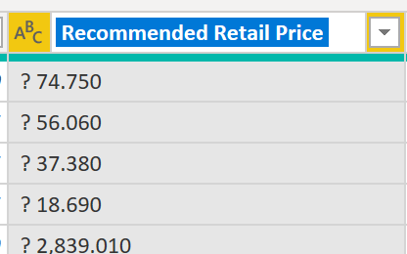



To fix this, use the Replace Values to change all question marks with spaces.

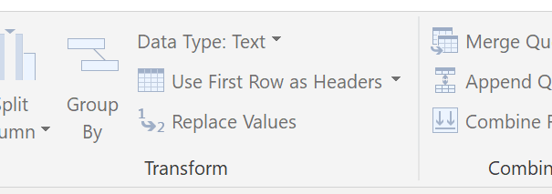



Highlight the Recommended Retail Price column, and hit Replace Values > type ? under Value To Find > do not enter anything in the Replace With textbox > select OK

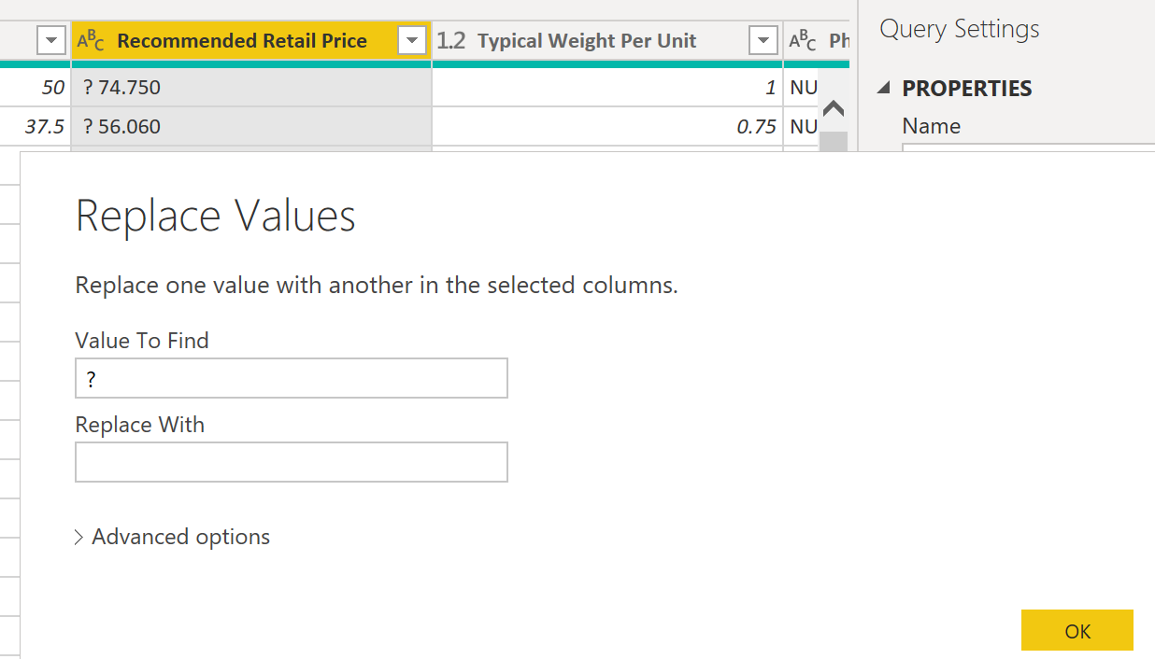



The question marks are now gone.

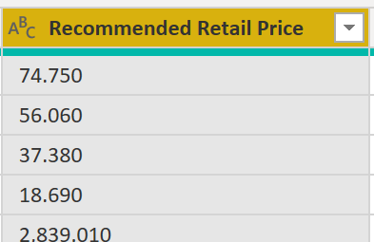



Also, the data type here is text 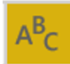, change it to decimal: Data Type: Text > Decimal Number

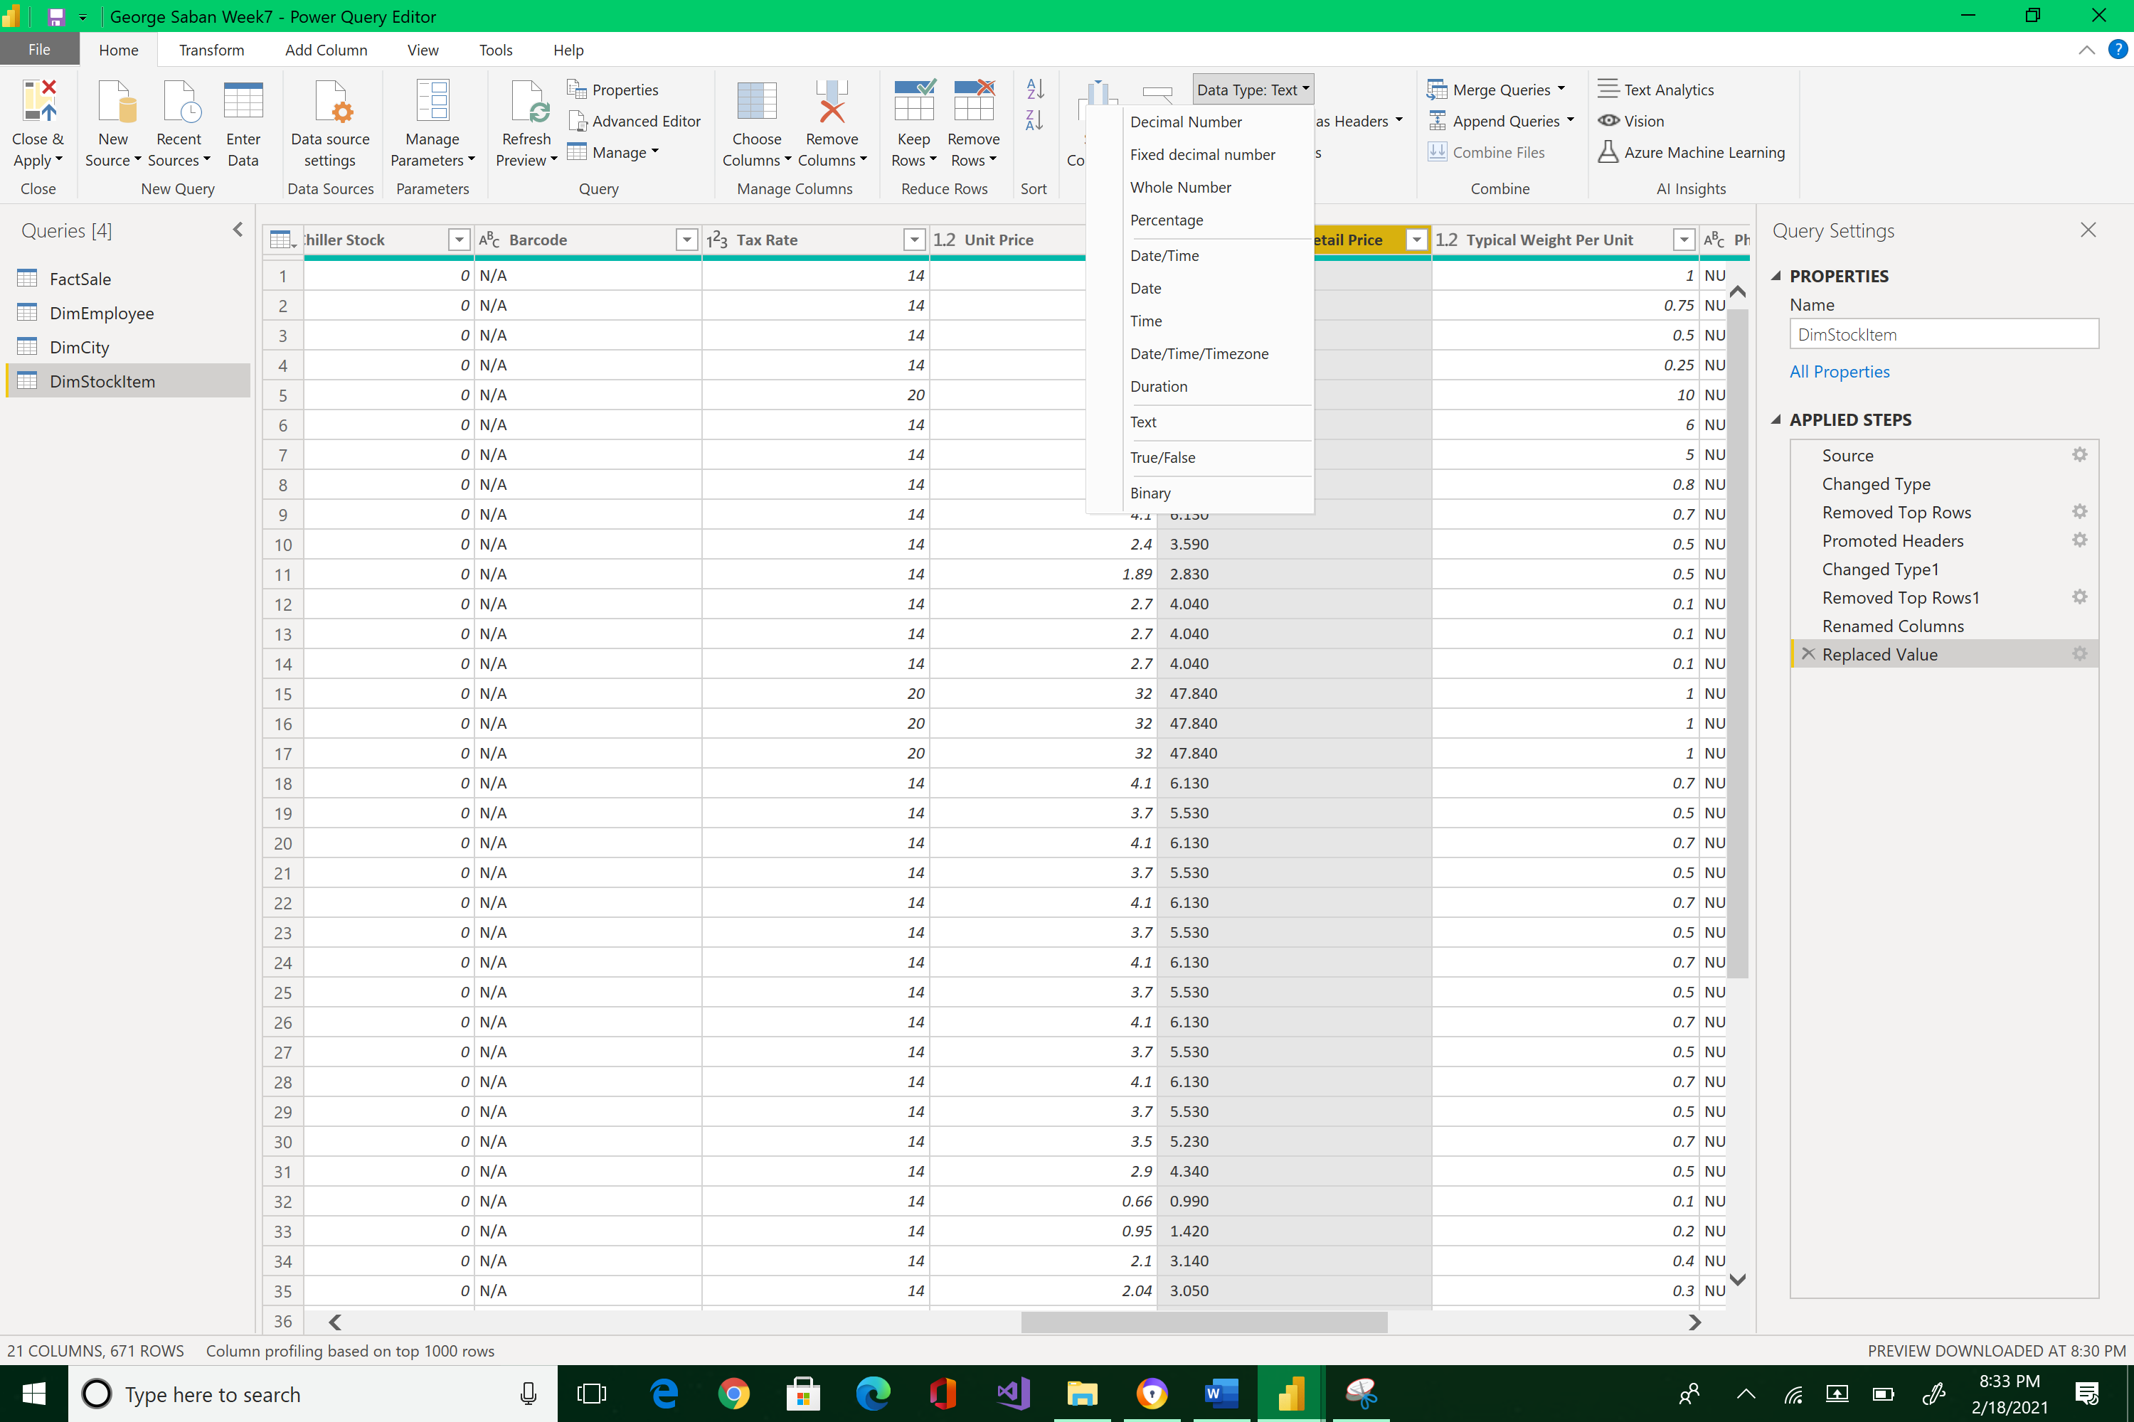



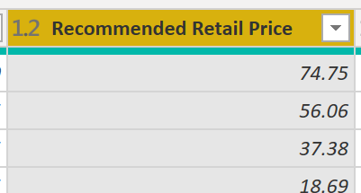



That’s much better!

Close & Apply to save changes.

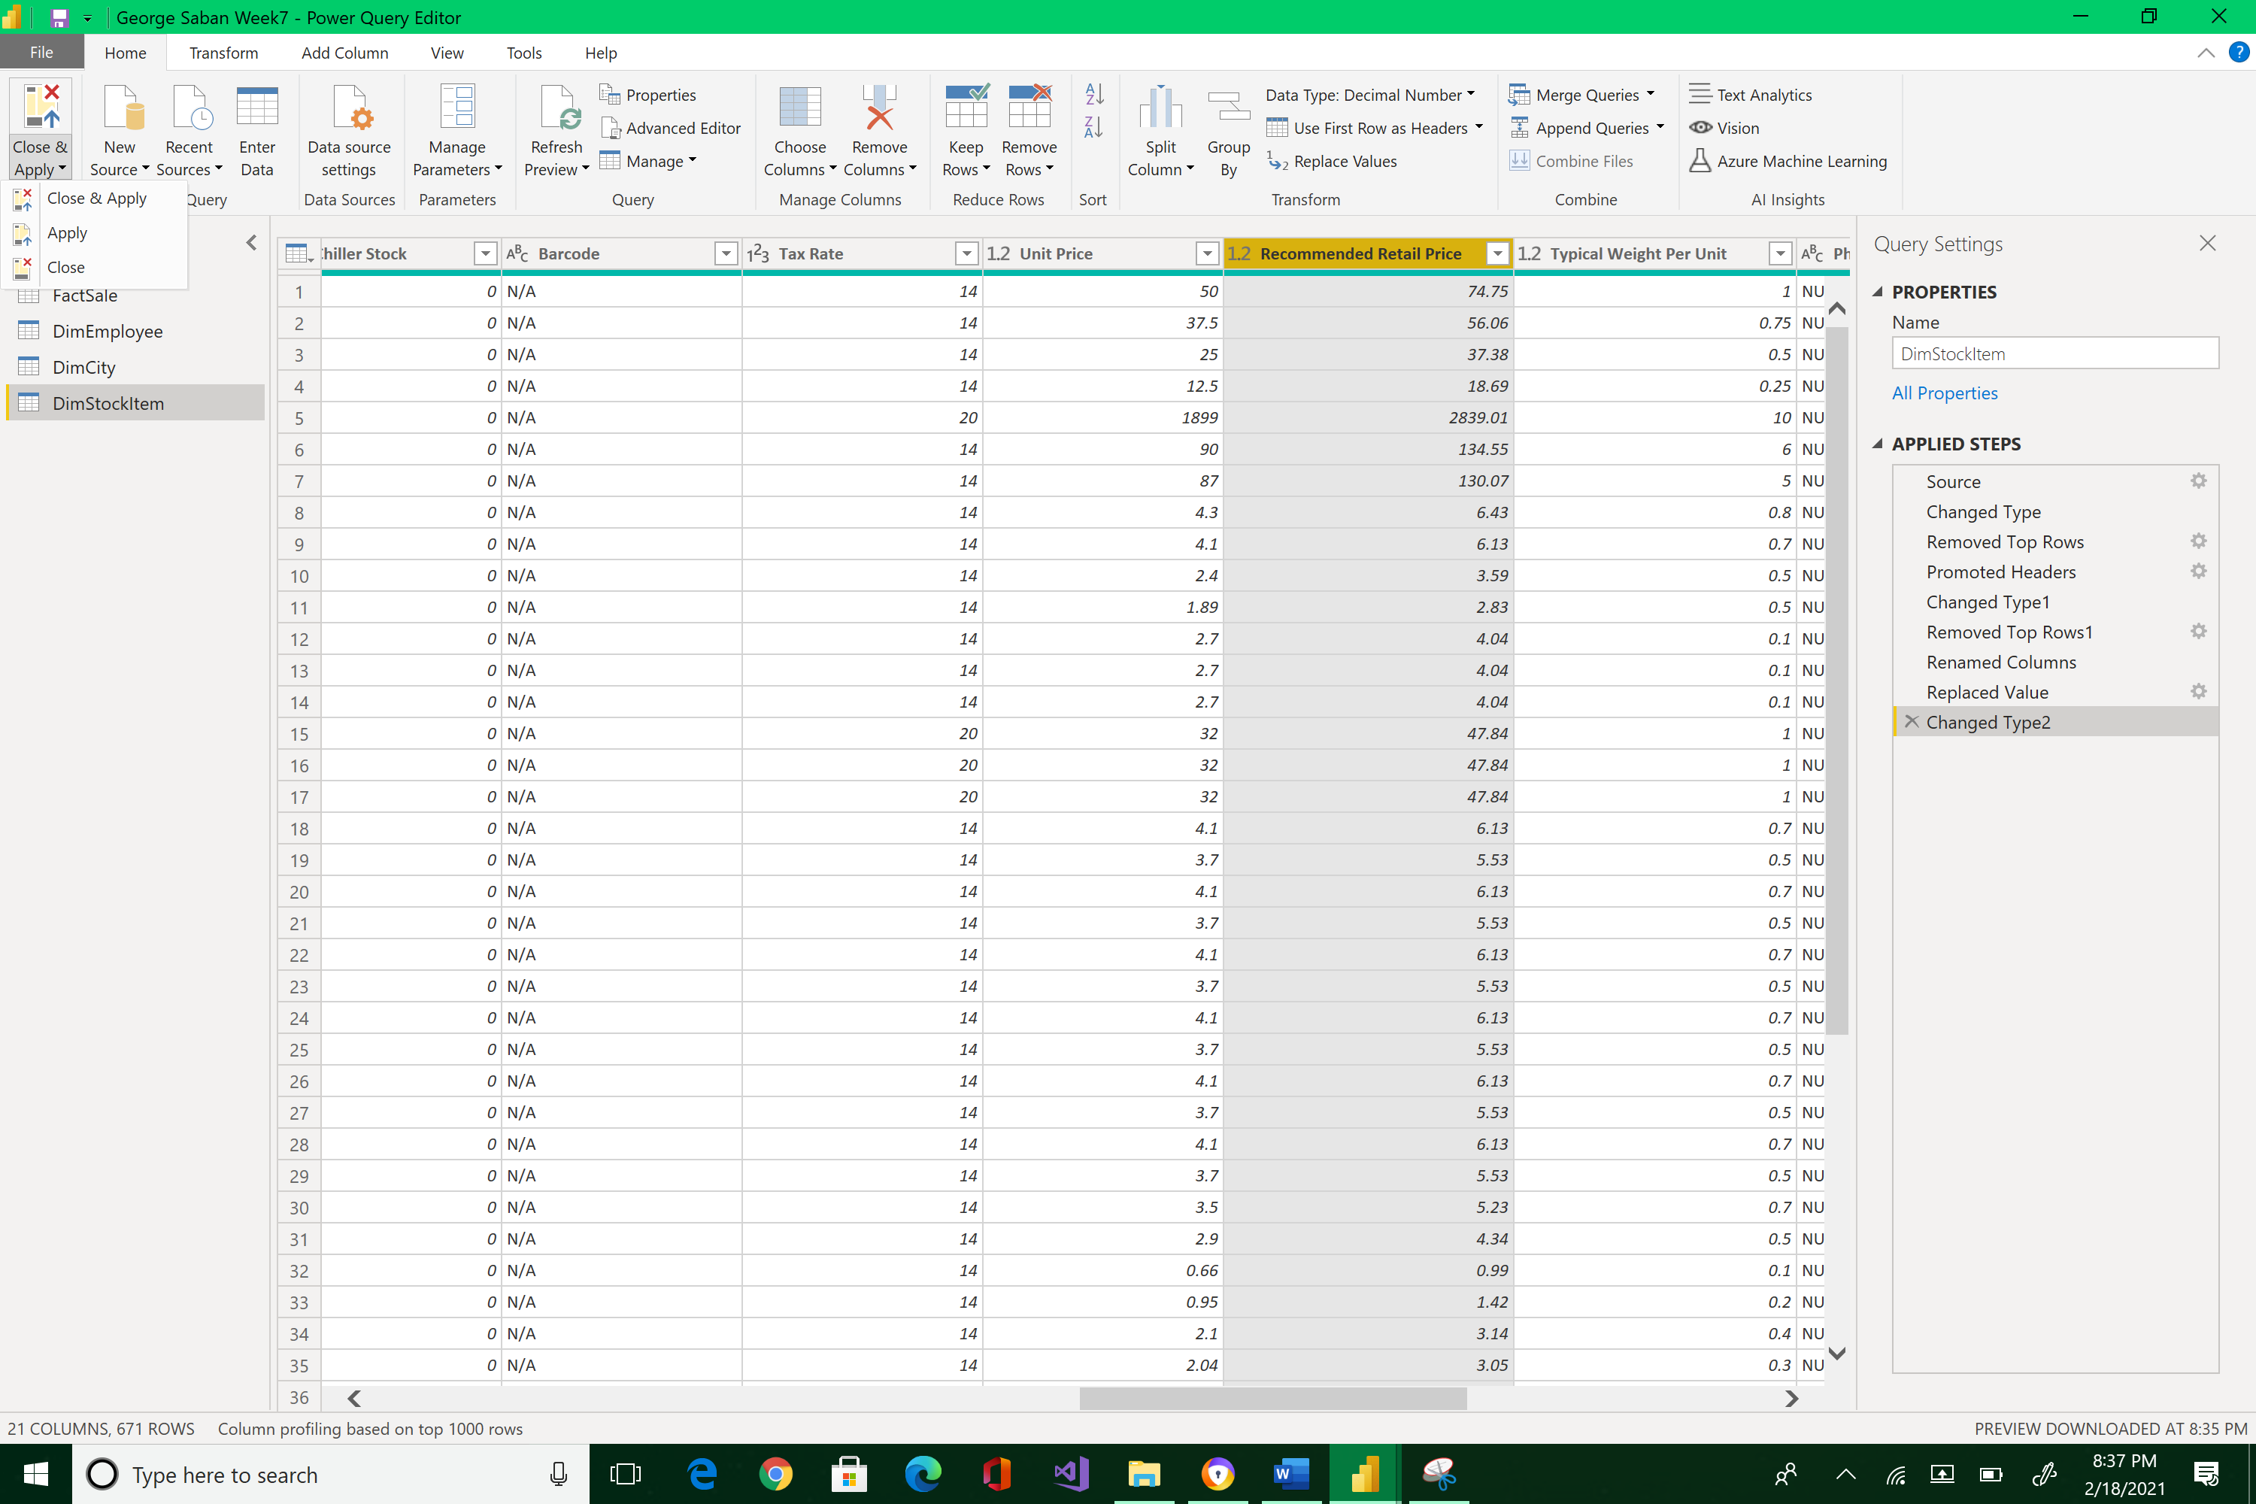



This action will bring you back to the Report View.

Now, let’s format our data so we can display currency in a card for the graphs.

Go back to the Data view > select Unit Price from the FactSale table. Note how it will highlight the entire Unit Price column.

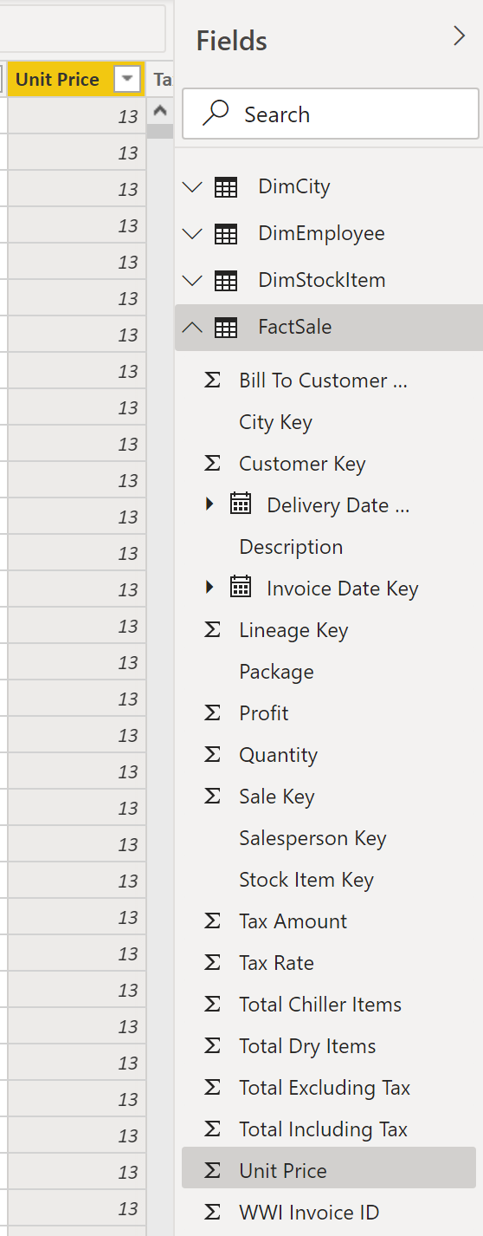



Most importantly, the Column tools will appear above.

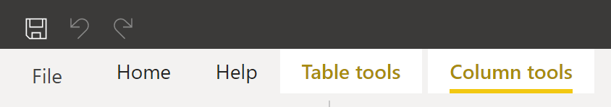



Change the format from Whole number to Currency.

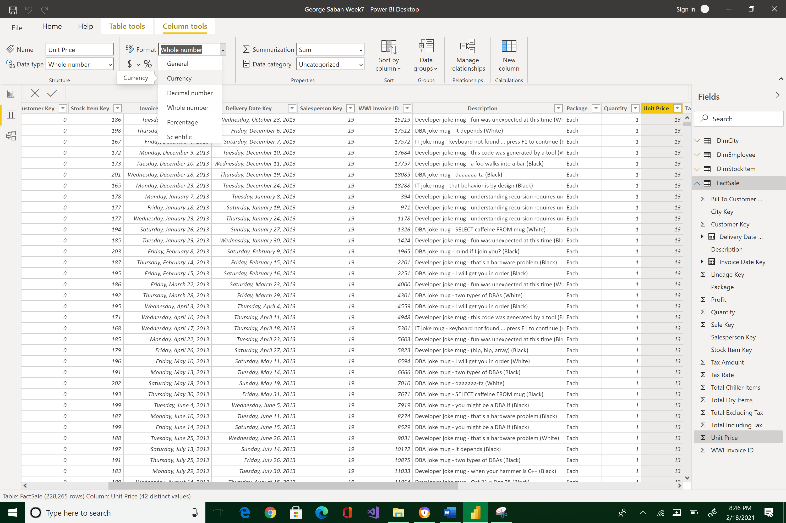



Unit Prices now has a $ symbol next to them.

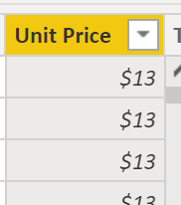



You can also force the decimal by pressing on the comma icon and type 2 decimals. Play around with this process until you get the desired Unit Price formatting result.

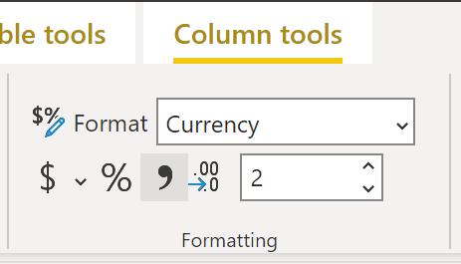 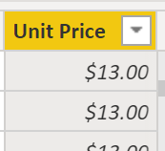



Use the Summarization field to change the default aggregate computation from Sum to Average.

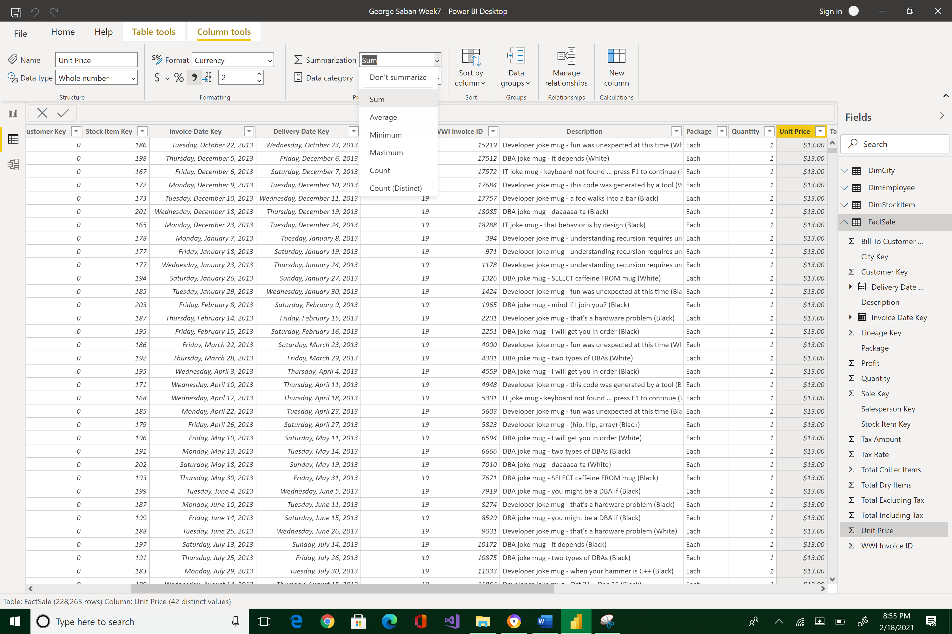



The default calculation is now Average.

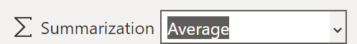

Go back to the Report view > Add a Card > and select Unit Price from the FactSale as your Card’s data. Rearrange your visualization styles so they would look like the layout below.

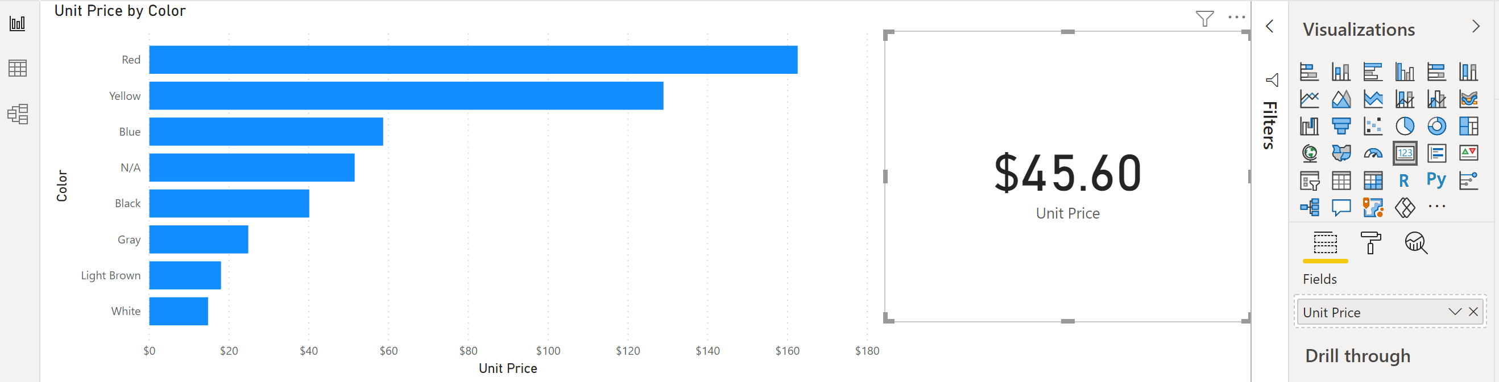



Note how the Card’s display is in currency format as well as the label of the Clustered bar chart.

Now, let’s look at geographic data. Go back to the Data view and select DimCity table. There are several fields here that relate to the geographic location such as City. You can place this information in a Data category.

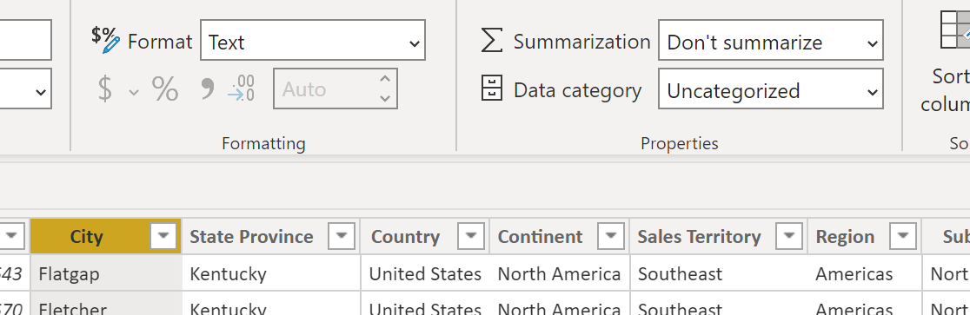



Highlight City field > click arrow down of Data category > select City

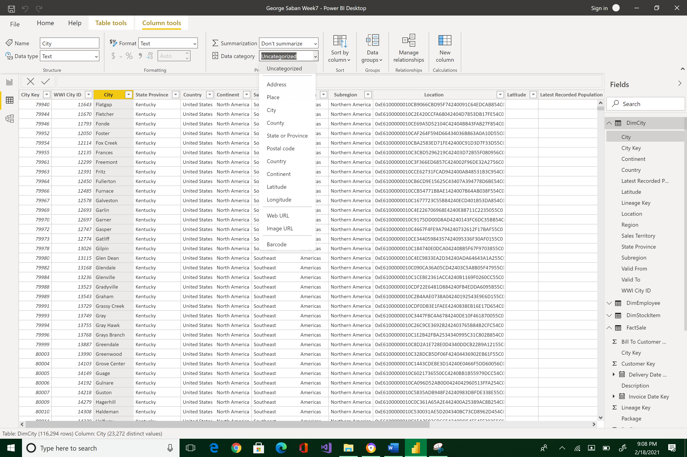



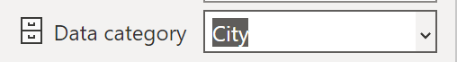

Next, highlight Continent > click arrow down of Data category > select Continent

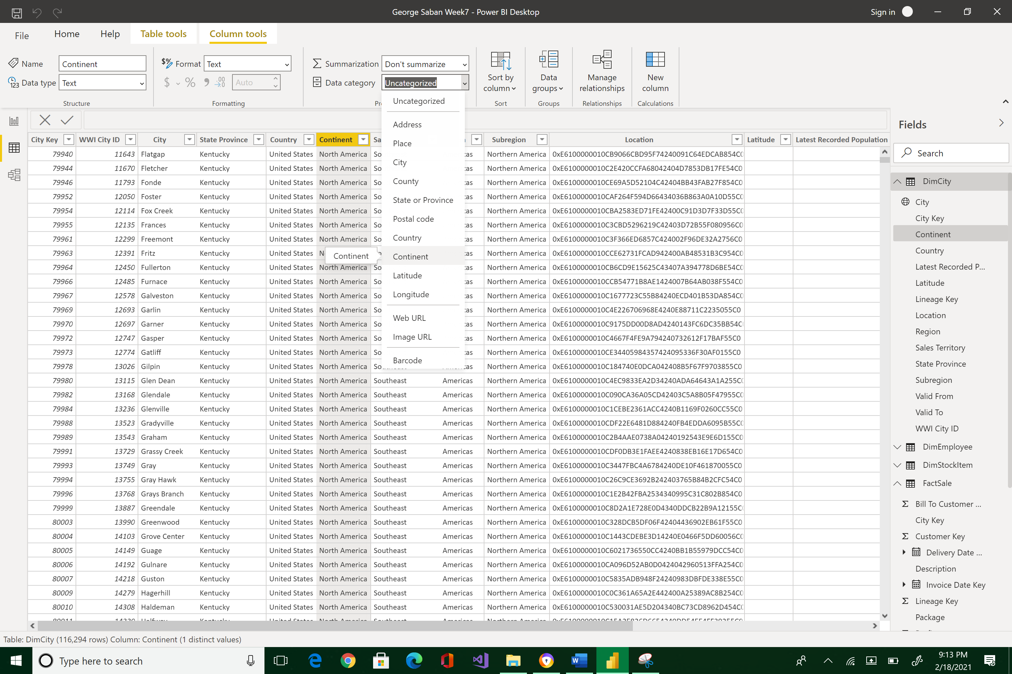



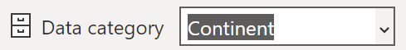

Data categories allows us to specify what type of geographic data the columns contain. Using these categories will enable us to use a Map visualization. Note that the globe icon has shown up next to the City and Continent fields indicating that they are recognized as geographic values by Power BI.

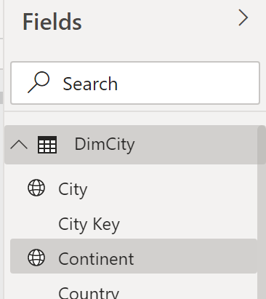



Switch back to the Report view. We can use the City as the location. Click on City.

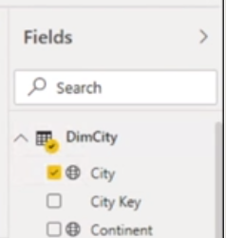



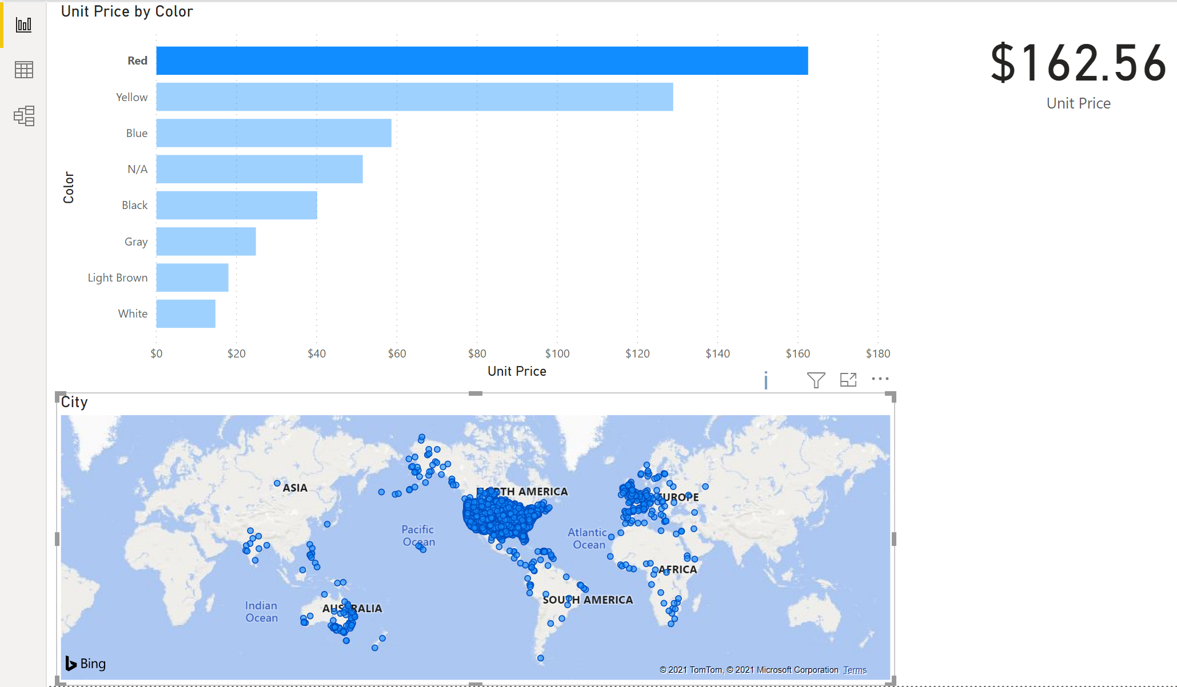

Note how a Map widget was automatically used as the visualizer. You may have to rearrange your UI display to match the above.

Select Quantity field from the FactSale table.

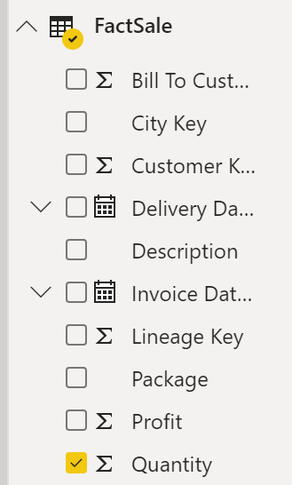



Now, the bubbles in the Map are proportional to the items sold in each location.

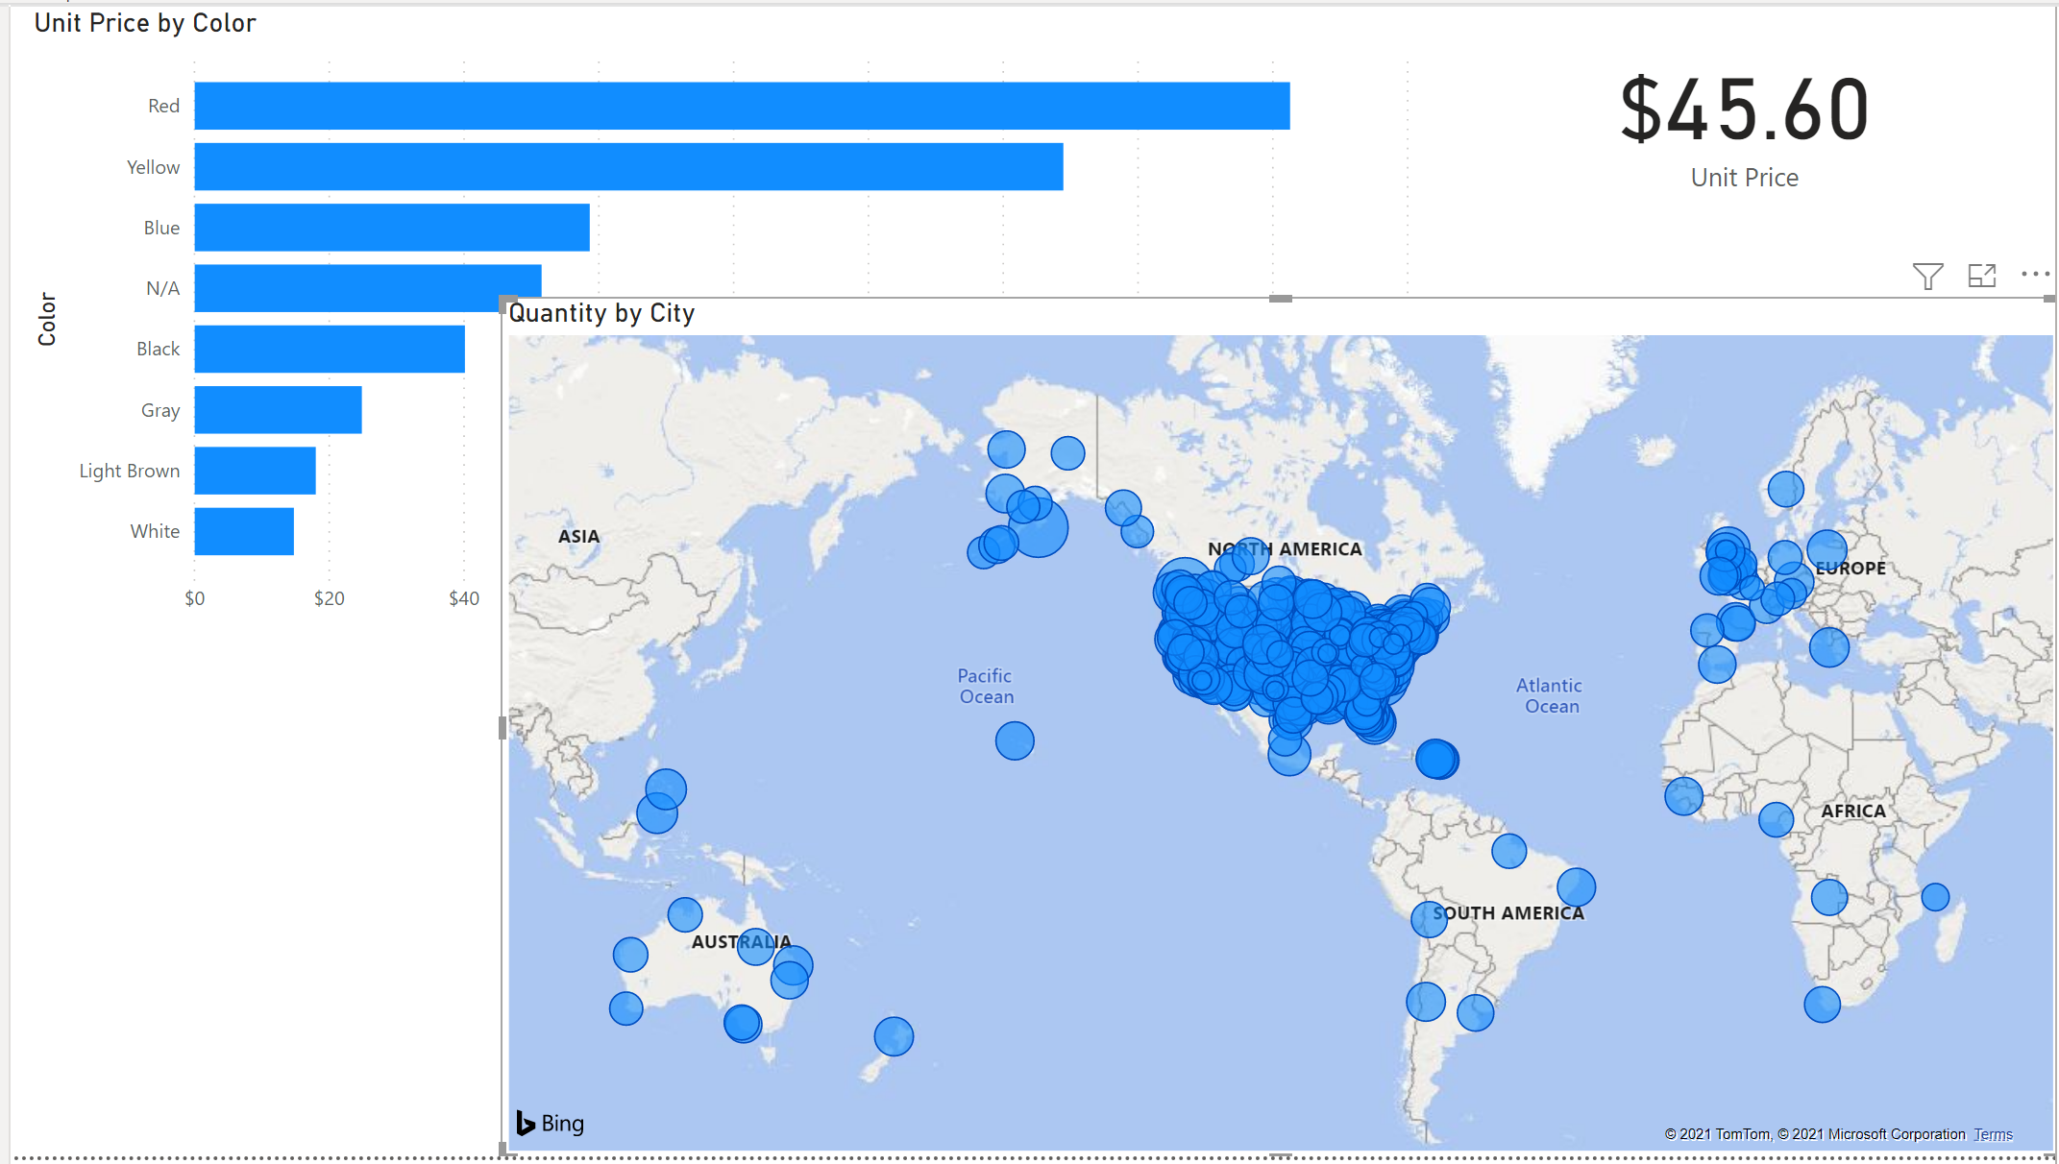

You can see that City is automatically added to the Location pane and Quantity to Size.

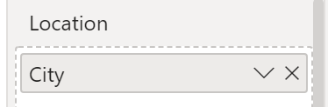 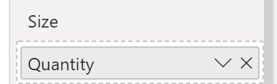



Please reposition your screen so that it would look like the image below. Take a snapshot using Window's Snipping Tool. Make sure the encircled items are included. Submit to Canvas in PNG format.  Thank you!

